

A Project Report on

**“T`APPRENTICE”**

Submitted by

**Nisha Chawda - 1480004**

**Hetal Desai - 1480008**

**Pranjal Naringrekar - 1480023**

Guided By

**Mr. Janardhan Kulkarni**

Term – December’16 to April’17

Department of Computer Engineering/Information Technology

SVKM’s

Shri Bhaghubhai Mafatlal Polytechnic, Irla, N.R.G. Marg, Vile Parle (W), Mumbai - 400056



**T’APPRENTICE**

**TABLE OF CONTENTS**

1. ACKNOWLEDGEMENT……………………………………...........5
2. PROBLEM DEFINITON…………………………………………...8
3. ABSTRACT………………………………………………………...10
4. INTRODUCTION………………………………………………….12
5. SOFTWARE REQUIREMENTS………………………………….16
6. HARDWARE REQUIREMENTS………………………………...21
7. DIAGRAMS………………………………………………………..23
8. WORKING PRINCIPLE…………………………………………..29
9. TIMELINE CHART……………………………………………….33
10. SOURCE CODE……………………………………………………35
11. SCREEN SHOTS………………………………………………….63
12. ADVANTAGES…………………………………………………....72
13. LIMITATIONS………………………………………………....….74
14. APPLICATIONS………………………………………………......76
15. FUTURE SCOPE………………………………………………....78
16. CONCLUSION…………………………………………………....80
17. REFERENCES…………………………………………………….82
18. ABOUT US……………………………………………………….84

**LIST OF FIGURES**

1. INTRODUCTION TO T’APPRENTICE..........................................14
2. VISUAL STUDIO...............................................................................17
3. SQL SERVER MANAGEMENT STUDIO.........................................19
4. FLOW CHART...................................................................................24
5. DFD-LEVEL 0......................................................................................25
6. DFD-LEVEL 1....................................................................................26
7. ADMIN USER CASE..........................................................................27
8. DEPLOYMENT...................................................................................28
9. COMPONENTS...................................................................................28
10. SEQUENCE OF EXECUTION..........................................................31
11. HOME PAGE........................................................................................64
12. ADMIN LOGIN PAGE.........................................................................64
13. ADMIN HOME PAGE..........................................................................65
14. FEEDBACK CLUSTER PAGE............................................................65
15. UPLOAD PAGE...................................................................................66
16. ADMIN MARKS PAGE.......................................................................66
17. PREDICTION PAGE............................................................................67
18. STUDENT HOME PAGE.....................................................................67
19. UPLOAD PAGE....................................................................................68
20. ADMIN PREDICTION PAGE...........................................................68
21. STUDENT LOGIN PAGE..................................................................69
22. SURVEY PAGE.................................................................................69
23. FEEDBACK PAGE............................................................................70
24. PT 1 PAGE.........................................................................................70
25. ABOUT US PAGE.............................................................................71
26. CONTACT US PAGE........................................................................71



**ACKNOWLEDGEMENT**

**ACKNOWLEDGEMENT**

________________________________________________________

We would like to express our gratitude and appreciation to all those who gave us the possibility to plenary this project.

We’d like to take this contingency and thank Shri Bhagubhai Mafatlal Polytechnic’s dean Prof. Y. I. Shah and Head of department (H.O.D) of Computer Science Engineering Mr. J. S. Kulkarni for their perpetual support and guidance in making this project a reality.

We’d also like to thank our project guide Mr. J. S. Kulkarni for being there with us at every milestone of the project and our technician Mr. Chetan Desai for helping us with the technical issues.

We would also like to acknowledge with much appreciation the crucial role of the staff of Computer Science Engineering who guided us in our difficulties and gave us the permission to use the resources to make the project a success.

Last but not the least, we’d like to thank our family and friends for their perpetual moral support. Without all the people mentioned, this project wouldn’t have ever seen the light of day.



**PROBLEM DEFINITION**

**PROBLEM DEFINITION**

________________________________________________________

“Education is the most powerful weapon we can use to change the world”

The education institutes are dispersed across the world which subsume most of the young generation of the nation. It is very paramount for any nation to give the best quality of education to them as they are the key for rebuilding the nation.

Since it is a very crucial and laboured task for the faculty of the educational institutes to manage the student’s data we have proposed T’apprentice. In today’s world it is tough to analyse the student’s performance and aid them with the respective topics so as to condense the ratio of the failed students.

T’apprenticeis a web portal that affirms the management of student data. For security we have urged two logins that is admin login or faculty login and student login. It not only stores the student data but also performs analysis on that data for the future prediction. It aids the teaching faculty to improve the teaching-learning process.

It provides forms to gain information from the students and avoid the burden of the teacher to enter data manually into the database. It also provides a chunk for attendance and marks where the teaching faculty can upload the attendance and marks of the students and student can see the respective.



**ABSTRACT**

**ABSTRACT**

________________________________________________________

T’apprentice is a project contemplated for college management system. It focuses on the management of student data and its analysis. It is a system that not only monitors the students’ performance but also allows students to witness their attendance and marks. This benefits every individual to cope up with their performance.

This project spotlights on the various aspects of any educational institute. We have deliberated the software and hardware requirements along with its working principle. Also, as it went on advancing we have focused on its source code and respective screen shots. This project also weighs the advantages, limitations and the future scope.



**INTRODUCTION**

**INTRODCUTION**

________________________________________________________

The main issue faced in today’s world for an education institute is to maintain the student data. Also another dominant issue faced is security. The student data that is entered can be spurious data due to human erratum.

T’apprentice is a web portal that affirms the management of student data. The main intent of the project is to revamp the services provided by the Microsoft Visual Studio and SQL Server Management Studio and perform data analysis for faculty. In this, different utility like forms, surveys, attendance and marks are used. The student data is amassed through forms and surveys and is stored in SQL database which is then used for analysis.

T’ apprentice provides :

* Admin and student login
* Maintenance of student data
* Gathering information through forms
* Attendance and marks
* Uploading assignments
* Analysing student’s performance
* Future prediction

Peculiar data of student is gathered like their marks, feedbacks and course exit data through the surveys and forms. This data is then stored in the database. The data from the database can be exported to another database or excel file which is further used for analysis.

________________________________________________________

The analysis is done depending on the stipulation of the faculty to enhance the performance of the students. Analysis can be conducted on the data possessed like analysing the periodic test marks to know about the understanding of the student for a respective subject and analysing the feedbacks of the student to revamp the teaching-learning process.

**Figure 1. Introduction To T’apprentice**

________________________________________________________

Our project not only manage and analyse the collected data but also :

* Provides efficiency
* Minimizes the burden of faculty
* Improves the teaching learning process
* Monitors the activity of students

The expense to deploy this project is very minor which only includes hosting charges. The amount of storage is also limited. Analysis can be performed online and report generated can be download in excel format.



**SOFTWARE REQUIREMENTS**

**VISUAL STUDIO 2013 ULTIMATE**

________________________________________________________

Microsoft Visual Studio is an integrated development environment (IDE) from Microsoft. It is used to develop computer programs for Microsoft Windows, as well as web sites, web apps, web services and mobile apps. Visual Studio uses Microsoft software development platforms such as Windows API, Windows Forms, Windows Presentation Foundation, Windows Store and Microsoft Silverlight. It can produce both native code and managed code.

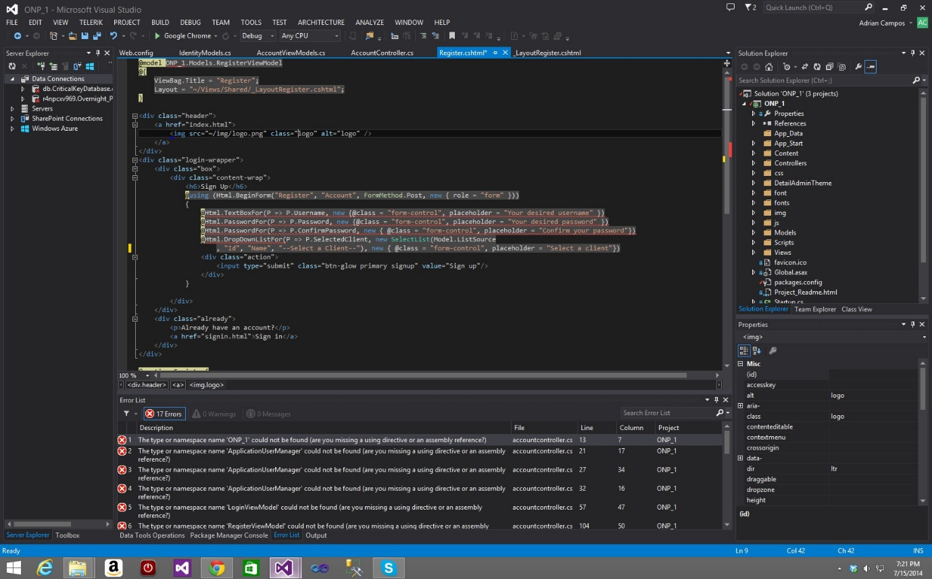

**Figure 2. Visual Studio**

Visual Studio includes a code editor supporting IntelliSense (the code completion component) as well as code refactoring. The integrated debugger works both as a source-level debugger and a machine-level debugger. Other built-in tools include a code profiler, forms designer for building GUI applications, web designer, class designer, and database schema designer.

________________________________________________________

We have used visual studio to create entire web portal. The designing is done using ASP.NET and the logical coding is done using C#. ASP.NET is an open-source server-side web application framework designed for web development to produce dynamic web pages. C# is one of many .NET programming languages.

**SQL SERVER MANAGEMENT STUDIO 2012**

_______________________________________________________

Microsoft SQL Server is a relational database management system developed by Microsoft. As a database server, it is a software product with the primary function of storing and retrieving data as requested by other software applications which may run either on the same computer or on another computer across a network.

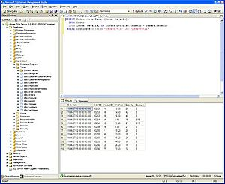

**Figure 3. SQL Server Management Studio**

Microsoft markets at least a dozen different editions of Microsoft SQL Server, aimed at different audiences and for workloads ranging from small single-machine applications to large Internet-facing applications with many concurrent users.

________________________________________________________

Data storage is a database, which is a collection of tables with typed columns. SQL Server supports different data types, including primary types such as Integer, Float, Decimal, Char (including character strings), Varchar (variable length character strings)/.



**HARDWARE REQUIREMENTS**

**HARDWARE REQUIREMENTS**

________________________________________________________

* 2 GB RAM
* Windows 10 Operating System
* 2 GB Hard disk
* Intel i3 processor



**DIAGRAMS**

**Figure 4. Flow Chart**

**Figure.5. DFD-LEVEL 0**

**Figure.6. DFD-LEVEL 1**

**Figure.7. ADMIN USER CASE**

**Figure.8. DEPLOYMENT**

**Figure.9. COMPONENTS**

**WORKING PRINCIPLE**

**WORKING PRINCIPLE**

________________________________________________________

The main issue faced by any educational institute is to regulate student data and predict its performance to boost the teaching-learning process. It was a challenging task for any institute to spawn such a system as it is time consuming and requires high level security. This is so because it is the student records and marks that should not be manipulated by any one.

T’apprentice is a web portal developed for college. There are mainly two logins that is admin login and student login.

The admin is the teaching faculty of an educational institute. Admin upload assignments that’s required to be solved by the students. The admin is liable for entering marks and attendance of a student. He/she can also import the forms filled by the students in the form of an excel sheet. Lastly admin is also responsible for monitoring the performance of the students and predict their future performance. The analysis is performed with C# coding and the output is in the form of a graph and table.

Student login consist of a new student registration field which allows any student to register itself in the system. Student field has static forms like survey, PT 1, PT 2 and feedback which is submitted by them and analysed by the teaching faculty. Students can glimpse and download the assignment given by the faculty. Lately they also can view their marks and attendance to improve their performance.

**Figure 10. Sequence Of Execution**

________________________________________________________

All the data is stored in the SQL server management studio. Different tables are spawned to store data in respective table. Different tables like login table, analysis table are created. Unified designing is done in the visual studio using ASP.NET. and logical coding is also done in visual studio using C#.

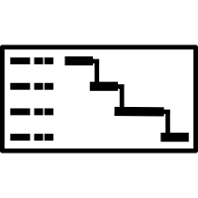

**TIMELINE CHART**

**TIMELINE CHART**

________________________________________________________

|  |  |  |  |  |  |  |  |  |  |  |  |  |  |  |  |  |
| --- | --- | --- | --- | --- | --- | --- | --- | --- | --- | --- | --- | --- | --- | --- | --- | --- |
| **Weeks :** | **1** | **2** | **3** | **4** | **5** | **6** | **7** | **8** | **9** | **10** | **11** | **12** | **13** | **14** | **15** | **16** |
| **Analysis** |  |  |  |  |  |  |  |  |  |  |  |  |  |  |  |  |
| **Design** |  |  |  |  |  |  |  |  |  |  |  |  |  |  |  |  |
| **Coding** |  |  |  |  |  |  |  |  |  |  |  |  |  |  |  |  |
| **Testing** |  |  |  |  |  |  |  |  |  |  |  |  |  |  |  |  |
| **Modification** |  |  |  |  |  |  |  |  |  |  |  |  |  |  |  |  |
| **Review** |  |  |  |  |  |  |  |  |  |  |  |  |  |  |  |  |
| **Result** |  |  |  |  |  |  |  |  |  |  |  |  |  |  |  |  |



**SOURCE CODE**

**WEBCONFIG.ASPX.CS**

________________________________________________________

<?xml version="1.0"?>

<!--

For more information on how to configure your ASP.NET application, please visit

http://go.microsoft.com/fwlink/?LinkId=169433

-->

<configuration>

<appSettings>

<add key="ChartImageHandler" value="storage=file;timeout=20;dir=c:\TempImageFiles\;" />

</appSettings>

<system.webServer>

<validation validateIntegratedModeConfiguration="false" />

<handlers>

<remove name="ChartImageHandler" />

<add name="ChartImageHandler" preCondition="integratedMode" verb="GET,HEAD,POST"

path="ChartImg.axd" type="System.Web.UI.DataVisualization.Charting.ChartHttpHandler,

________________________________________________________

System.Web.DataVisualization, Version=4.0.0.0, Culture=neutral, PublicKeyToken=31bf3856ad364e35" />

</handlers>

</system.webServer>

<connectionStrings>

<add name="connect" connectionString="Server=HP;Database=student_perf;Integrated Security=True"/>

</connectionStrings>

<system.web>

<httpHandlers>

<add path="ChartImg.axd" verb="GET,HEAD,POST" type="System.Web.UI.DataVisualization.Charting.ChartHttpHandler, System.Web.DataVisualization, Version=4.0.0.0, Culture=neutral, PublicKeyToken=31bf3856ad364e35"

validate="false" />

</httpHandlers>

<pages theme="theme1">

<controls>

<add tagPrefix="asp" namespace="System.Web.UI.DataVisualization.Charting"

________________________________________________________

assembly="System.Web.DataVisualization, Version=4.0.0.0, Culture=neutral, PublicKeyToken=31bf3856ad364e35" />

</controls>

</pages>

<compilation debug="true" targetFramework="4.0">

<assemblies>

<add assembly="System.Web.DataVisualization, Version=4.0.0.0, Culture=neutral, PublicKeyToken=31BF3856AD364E35"/>

</assemblies>

</compilation>

</system.web>

</configuration>

HOM**E.ASPX**

________________________________________________________

<%@ Page Title="" Language="C#" MasterPageFile="~/Site1.Master" AutoEventWireup="true" CodeBehind="home.aspx.cs" Inherits="WebApplication1.WebForm1" %>

<asp:Content ID="Content1" ContentPlaceHolderID="head" runat="server">

</asp:Content>

<asp:Content ID="Content2" ContentPlaceHolderID="ContentPlaceHolder1" runat="server">

<p align="center">

<h1>T'APPRENTICE !!</h1>

</p>

<br />

<p align="justify">

T'APPRENTICE refers to teacher's assistant. The main issue faced in today’s world for an education institute is to enter the student data manually into the system which is very time consuming for the staff. Also another dominant issue faced is security. The student data that is entered can be spurious data due to human erratum.

<br />

<br />

**__________________________________________________________________________**

Peculiar data of student is gathered like their marks, feedbacks and course exit data through the surveys and forms. This data

is then stored in the internal database. The data from the database can be exported to another database or excel file which is further used for analysis.

The analysis is done depending on the stipulation of the faculty to enhance the performance of the students.

<br />

<br />

­­­­­­­­ Performance analysis can be conducted on the data possessed such as analyzing the periodic test marks to know about the understanding of the student for a respective subject, analyzing the feedbacks of the student to revamp the teaching-learning process.

Our project not only acts as a website and analyze the collected data but also:

<br />

<br />

<ul>

&nbsp;

<li>Provides efficiency </li>

&nbsp;

**__________________________________________________________________________**

<li>Minimizes the burden of faculty </li>

&nbsp;

<li>Improves the teaching learning process </li>

&nbsp;

<li>Monitors the activity of students </li>

</ul>

</p>

</asp:Content>**LOGIN.ASPX.CS**

**___________________________________________________________________________**

using System;

using System.Collections.Generic;

using System.Linq;

using System.Web;

using System.Web.UI;

using System.Web.UI.WebControls;

using System.Data;

using System.Data.SqlClient;

using System.Configuration;

using System.Net.Mail;

namespace WebApplication1

{

public partial class WebForm6 : System.Web.UI.Page

{

private string cs = ConfigurationManager.ConnectionStrings["connect"].ConnectionString;

SqlConnection conn;

________________________________________________________________________

SqlCommand comm;

SqlDataAdapter adp;

DataTable dt = new DataTable();

protected void Page_Load(object sender, EventArgs e)

{

conn = new SqlConnection(cs);

Label1.Visible = false;

}

protected void Button1_Click(object sender, EventArgs e)

{

using (comm = new SqlCommand("select * from student_master where email_id=@email_id and password_=@password_", conn))

{

comm.Parameters.AddWithValue("@email_id", TextBox1.Text);

comm.Parameters.AddWithValue("@password_", TextBox2.Text);

using (adp = new SqlDataAdapter(comm))

{

**_________________________________________________**__________________________

adp.Fill(dt);

}

if (dt.Rows.Count > 0)

{

Session["msg"] = TextBox1.Text;

Response.Redirect("student_home.aspx");

}

}

Label1.Visible = true;

}

protected void LinkButton1_Click(object sender, EventArgs e)

{

Response.Redirect("registration.aspx");

}

protected void LinkButton2_Click(object sender, EventArgs e)

{

**___________________________________________________________________________**

if (TextBox1.Text == "")

{

Response.Write("<script>alert('Enter email id!!')</script>");

}

else

{

string email = TextBox1.Text;

DataTable dt = new DataTable();

using (SqlCommand cmd = new SqlCommand("select password_ from student_master where email_id=@email_id", conn))

{

cmd.Parameters.AddWithValue("@email_id", email);

using (SqlDataAdapter adp = new SqlDataAdapter(cmd))

{

adp.Fill(dt);

}

}

string password = dt.Rows[0].ItemArray[0].ToString();

**___________________________________________________________________________**

SmtpClient smtpserver = new SmtpClient();

MailMessage mail = new MailMessage();

smtpserver.Credentials = new System.Net.NetworkCredential("project.tpo@gmail.com", "1234ABCD$");

smtpserver.Port = 587;

smtpserver.EnableSsl = true;

smtpserver.Host = "smtp.gmail.com";

mail = new MailMessage();

mail.From = new MailAddress("project.tpo@gmail.com");

mail.To.Add(email);

mail.Subject = "Registration Details";

mail.Body = "Your Login-id is : " + email + "\n" + "Your Password is : " + password;

smtpserver.Send(mail);

}

}

}

}

**ANALYSIS.ASPX.CS**

namespace WebApplication1

{

public partial class WebForm13 : System.Web.UI.Page

{

private string cs = ConfigurationManager.ConnectionStrings["connect"].ConnectionString;

SqlConnection conn;

SqlCommand comm;

SqlDataAdapter adp;

DataTable dt = new DataTable();

double bigdata1, snmr1, stqa1, csm1;

double bigdata2, snmr2, stqa2, csm2, bigdata_session, snmr_session, stqa_session, csm_session;

double sub_perf, ut_perf, att_perf;

DataTable dt9 = new DataTable();

protected void Page_Load(object sender, EventArgs e)

**___________________________________________________________________________**

{

conn = new SqlConnection(cs);

if (Session["id"] == null)

{

Response.Redirect("login.aspx");

}

else

{

Label1.Visible = false;

GridView2.Visible = false;

}

}

protected void LinkButton1_Click(object sender, EventArgs e)

{

Response.Redirect("admin_home.aspx");

}

**___________________________________________________________________________**

protected void LinkButton2_Click(object sender, EventArgs e)

{

Response.Redirect("review.aspx");

}

protected void LinkButton6_Click(object sender, EventArgs e)

{

Response.Redirect("Student_Prediction.aspx");

}

protected void LinkButton3_Click(object sender, EventArgs e)

{

Response.Redirect("marks_att.aspx");

}

protected void LinkButton4_Click(object sender, EventArgs e)

{

**___________________________________________________________________________**

Session.Abandon();

Session.Clear();

Response.Redirect("login.aspx");

}

protected void Button1_Click(object sender, EventArgs e)

{

GridView2.Visible = true;

Label1.Visible = true;

using (SqlCommand ccd6 = new SqlCommand("truncate table perf_transaction", conn))

{

conn.Open();

ccd6.ExecuteNonQuery();

conn.Close();

}

using (SqlCommand ccd6 = new SqlCommand("truncate table tmp_data", conn))

{

**___________________________________________________________________________**

conn.Open();

ccd6.ExecuteNonQuery();

conn.Close();

}

DataTable dt1 = new DataTable();

//for ut average

using (SqlCommand cd1 = new SqlCommand("select * from ut_marks_master", conn))

{

using (SqlDataAdapter adp1 = new SqlDataAdapter(cd1))

{

adp1.Fill(dt1);

}

}

double[] ut_bigdata = new double[dt1.Rows.Count];

double[] ut_snmr = new double[dt1.Rows.Count];

**___________________________________________________________________________**

double[] ut_stqa = new double[dt1.Rows.Count];

double[] ut_csm = new double[dt1.Rows.Count];

for (int i = 0; i < dt1.Rows.Count; i++)

{

bigdata1 = Convert.ToDouble(dt1.Rows[i].ItemArray[4]);

snmr1 = Convert.ToDouble(dt1.Rows[i].ItemArray[5]);

stqa1 = Convert.ToDouble(dt1.Rows[i].ItemArray[6]);

csm1 = Convert.ToDouble(dt1.Rows[i].ItemArray[7]);

ut_bigdata[i] = (bigdata1 / 100) * 100;

ut_snmr[i] = (snmr1 / 100) * 100;

ut_stqa[i] = (stqa1 / 100) * 100;

ut_csm[i] = (csm1 / 100) * 100;

}//-->

//for attendance

DataTable dt2 = new DataTable();

using (SqlCommand cd2 = new SqlCommand("select * from attendance_master", conn))

**___________________________________________________________________________**

{

using (SqlDataAdapter adp2 = new SqlDataAdapter(cd2))

{

adp2.Fill(dt2);

}

}

double[] att_bigdata = new double[dt2.Rows.Count];

double[] att_snmr = new double[dt2.Rows.Count];

double[] att_stqa = new double[dt2.Rows.Count];

double[] att_csm = new double[dt2.Rows.Count];

for (int i = 0; i < dt2.Rows.Count; i++)

{

bigdata2 = Convert.ToDouble(dt2.Rows[i].ItemArray[4]);

snmr2 = Convert.ToDouble(dt2.Rows[i].ItemArray[5]);

stqa2 = Convert.ToDouble(dt2.Rows[i].ItemArray[6]);

csm2 = Convert.ToDouble(dt2.Rows[i].ItemArray[7]);

bigdata_session = Convert.ToDouble(dt2.Rows[i].ItemArray[8]);

snmr_session = Convert.ToDouble(dt2.Rows[i].ItemArray[9]);

**___________________________________________________________________________**

stqa_session = Convert.ToDouble(dt2.Rows[i].ItemArray[10]);

csm_session = Convert.ToDouble(dt2.Rows[i].ItemArray[11]);

att_bigdata[i] = (bigdata2 / bigdata_session) * 100;

att_snmr[i] = (snmr2 / snmr_session) * 100;

att_stqa[i] = (stqa2 / stqa_session) * 100;

att_csm[i] = (csm2 / csm_session) * 100;

}

//for test marks

DataTable dt3 = new DataTable();

using (SqlCommand cd3 = new SqlCommand("select email_id from student_master", conn))

{

using (SqlDataAdapter adp3 = new SqlDataAdapter(cd3))

{

adp3.Fill(dt3);

}

}

**___________________________________________________________________________**

//DataTable dt5 = new DataTable();

for (int i = 0; i < dt3.Rows.Count; i++)

{

// using (SqlCommand cd5 = new SqlCommand("select count(*) from student_test as s,question_master as q where q.question_id=s.question_id and q.correct_answer=s.answer and student_id=@student_id and subject_=@subject_", conn))

// {

// cd5.Parameters.AddWithValue("@student_id", dt3.Rows[i].ItemArray[0]);

// cd5.Parameters.AddWithValue("@subject_", DropDownList2.SelectedValue);

// using (SqlDataAdapter adp5 = new SqlDataAdapter(cd5))

// {

// adp5.Fill(dt5);

// }

// }

//for calculation of performance value

**___________________________________________________________________________**

if (DropDownList2.SelectedValue == "bigdata")

{

ut_perf = ut_bigdata[i];

att_perf = att_bigdata[i];

}

else if (DropDownList2.SelectedValue == "snmr")

{

ut_perf = ut_snmr[i];

att_perf = att_snmr[i];

}

else if (DropDownList2.SelectedValue == "stqa")

{

ut_perf = ut_stqa[i];

att_perf = att_stqa[i];

}

**___________________________________________________________________________**

else if (DropDownList2.SelectedValue == "csm")

{

ut_perf = ut_csm[i];

att_perf = att_csm[i];

}

double total_avg = ((ut_perf + att_perf) / 2);

using (SqlCommand cd6 = new SqlCommand("insert into perf_transaction(stud_name, email_id, ut_avg, att_avg, total_avg,subject_) values(@stud_name, @email_id, @ut_avg, @att_avg, @total_avg,@subject_)", conn))

{

cd6.Parameters.AddWithValue("@stud_name", dt2.Rows[i].ItemArray[2]);

cd6.Parameters.AddWithValue("@email_id", dt2.Rows[i].ItemArray[3]);

cd6.Parameters.AddWithValue("@ut_avg", ut_perf);

cd6.Parameters.AddWithValue("@att_avg", att_perf);

cd6.Parameters.AddWithValue("@total_avg", total_avg);

cd6.Parameters.AddWithValue("@subject_", DropDownList2.SelectedValue);

**__________________________________________________________________________**_

conn.Open();

cd6.ExecuteNonQuery();

conn.Close();

}

}

//for graph

DataTable dt7 = new DataTable();

using (SqlCommand cd7 = new SqlCommand("select id_,total_avg from perf_transaction where subject_=@subject_", conn))

{

cd7.Parameters.AddWithValue("@subject_", DropDownList2.SelectedValue);

using (SqlDataAdapter adp7 = new SqlDataAdapter(cd7))

{

adp7.Fill(dt7);

}

}

**___________________________________________________________________________**

string[] x = new string[dt7.Rows.Count];

int[] y = new int[dt7.Rows.Count];

for (int i = 0; i < dt7.Rows.Count; i++)

{

x[i] = dt7.Rows[i].ItemArray[0].ToString();

y[i] = Convert.ToInt32(dt7.Rows[i].ItemArray[1]);

}

Chart1.Series[0].Points.DataBindXY(x, y);

string status_ = "";

for (int i = 0; i < dt7.Rows.Count; i++)

{

double classify = Convert.ToDouble(dt7.Rows[i].ItemArray[1]);

if (classify >= 0 && classify < 30)

{

status_ = "DROPOUT";

}

else if (classify >= 30 && classify < 55)

{

**___________________________________________________________________________**

status_ = "AVERAGE";

}

else if (classify > 55)

{

status_ = "GOOD";

}

using (SqlCommand cd8 = new SqlCommand("insert into tmp_data(name_, status_) values(@name_, @status_)", conn))

{

cd8.Parameters.AddWithValue("@name_", dt7.Rows[i].ItemArray[0]);

cd8.Parameters.AddWithValue("@status_", status_.ToString());

conn.Open();

cd8.ExecuteNonQuery();

conn.Close();

}

}

using (SqlCommand cd9 = new SqlCommand("select * from tmp_data", conn))

{

**___________________________________________________________________________**

using (SqlDataAdapter adp9 = new SqlDataAdapter(cd9))

{

adp9.Fill(dt9);

}

}

GridView2.DataSource = dt9;

GridView2.DataBind();

}

protected void LinkButton6_Click1(object sender, EventArgs e)

{

Response.Redirect("upload.aspx");

}

protected void LinkButton4_Click1(object sender, EventArgs e)

{

Session.Abandon();

Session.Clear();

**___________________________________________________________________________** Session.Clear();

Response.Redirect("../home.aspx");

}

protected void LinkButton4_Click2(object sender, EventArgs e)

{

Session.Abandon();

Response.Redirect("../home.aspx");

}

}

}



**SCREEN SHOTS**

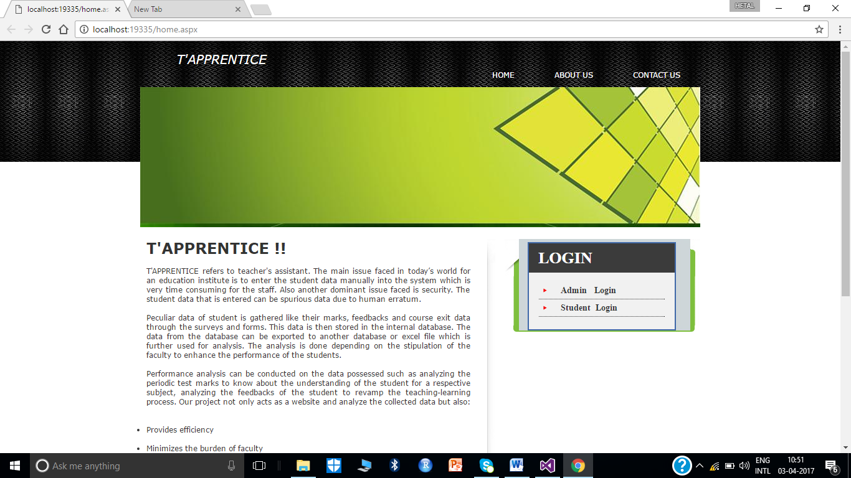

**Figure 11. Home Page**

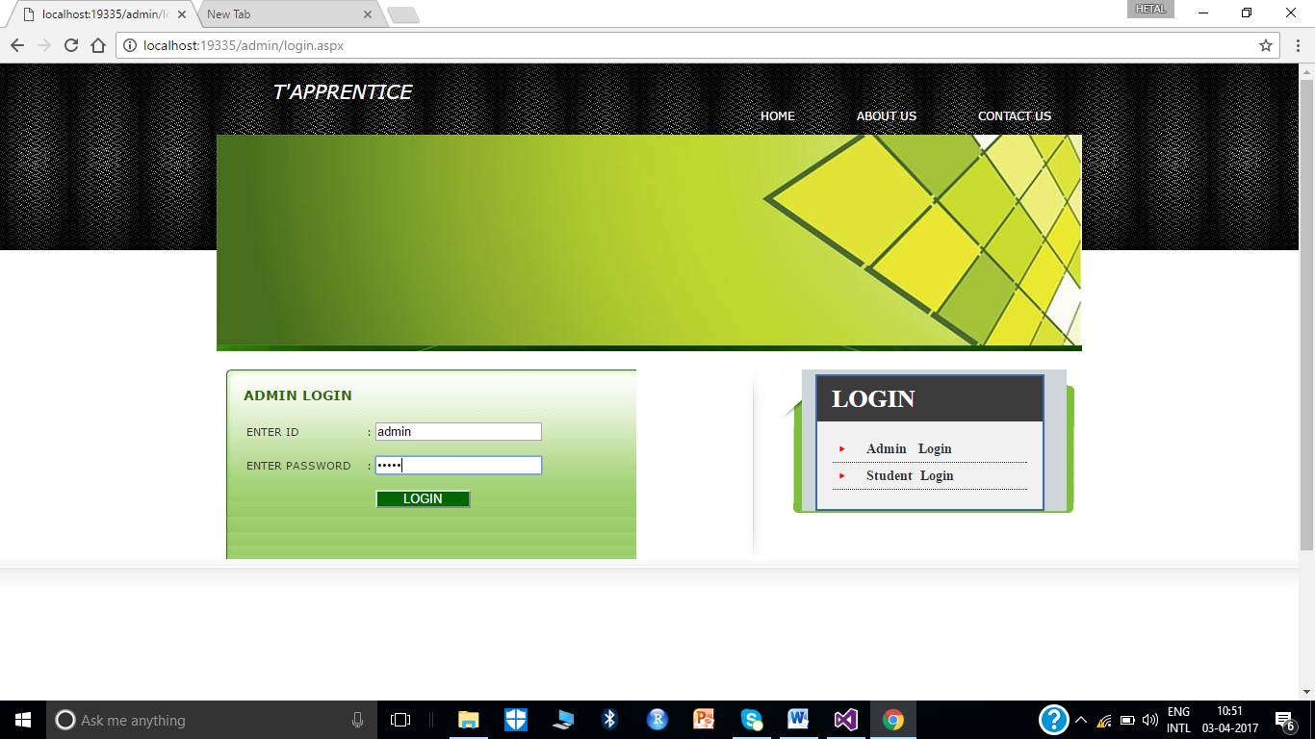

**Figure 12. Admin Login Page**

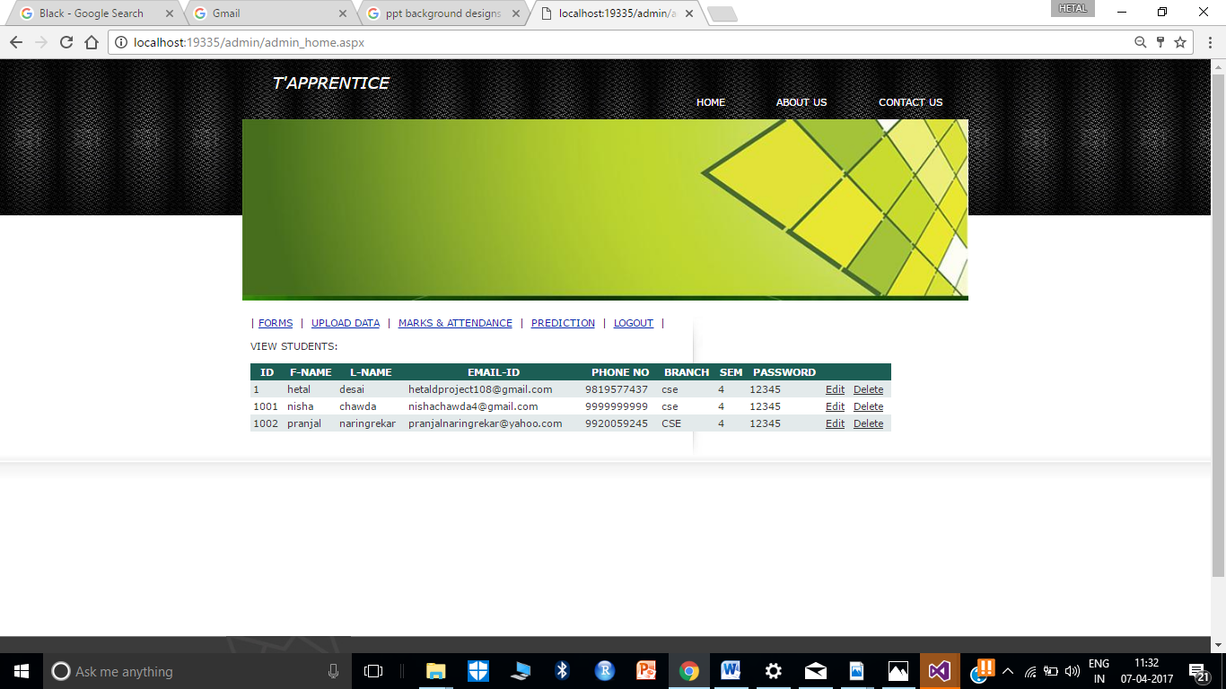

**Figure 13. Admin Home Page**

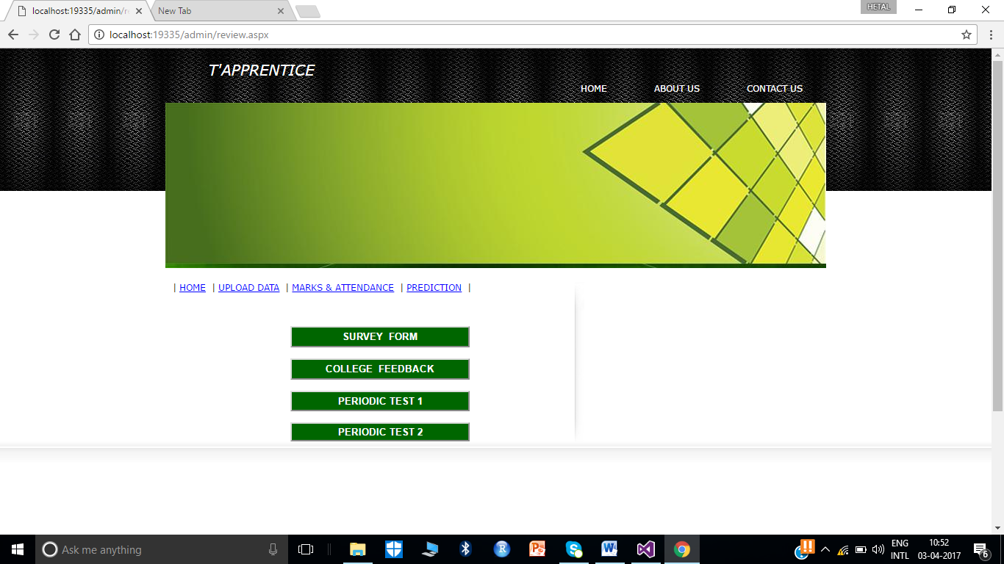

**Figure 14. Feedback Cluster Page**

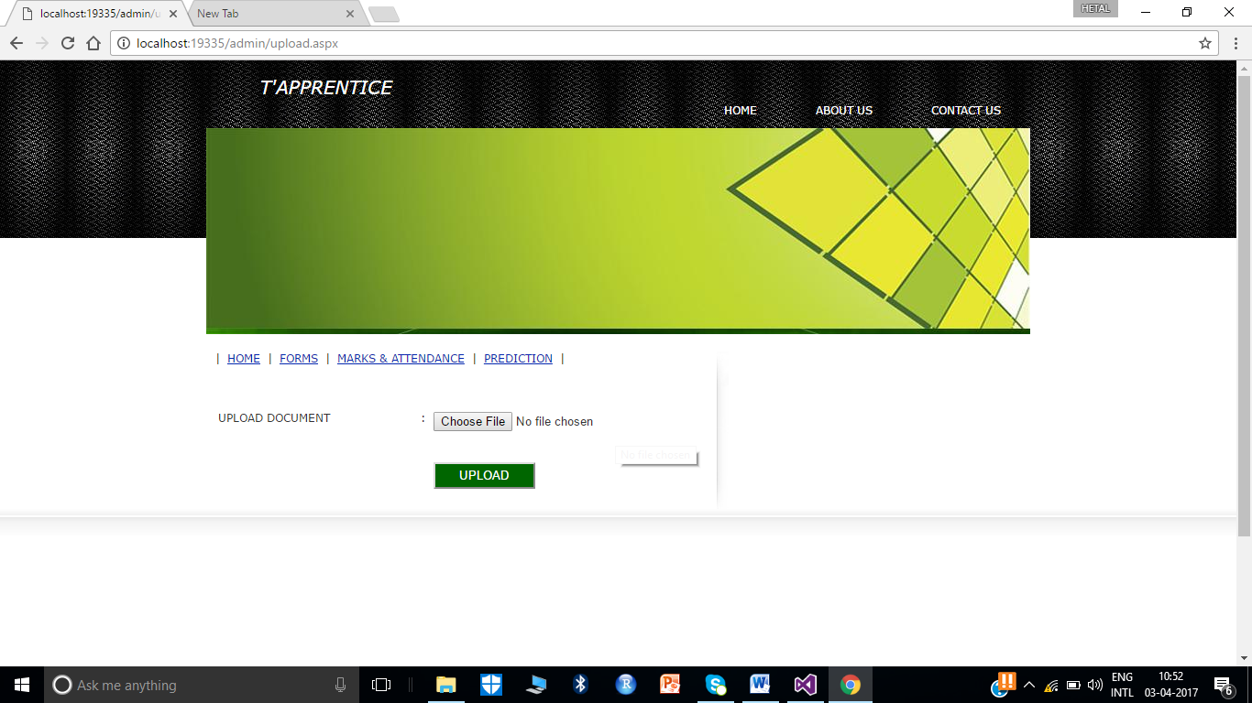

**Figure 15. Upload Page**

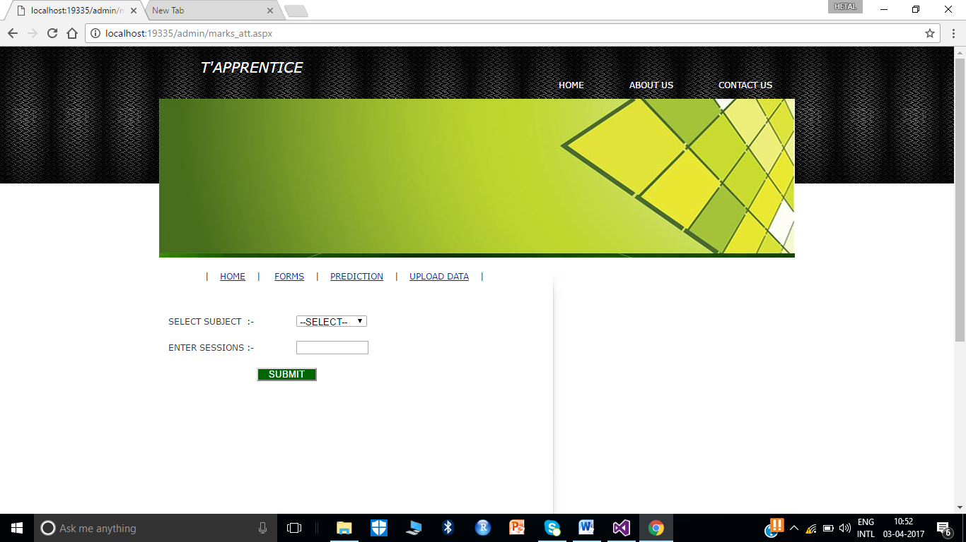

**Figure 16. Admin Marks Page**

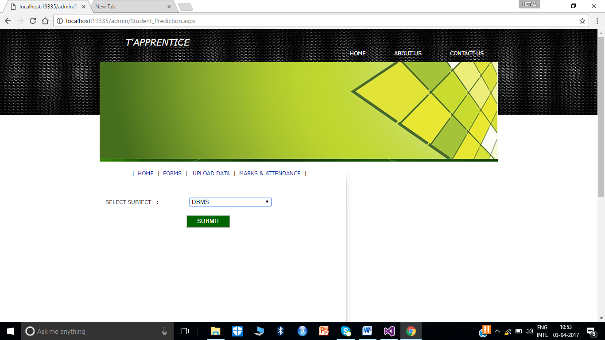

**Figure 17. Prediction Page**

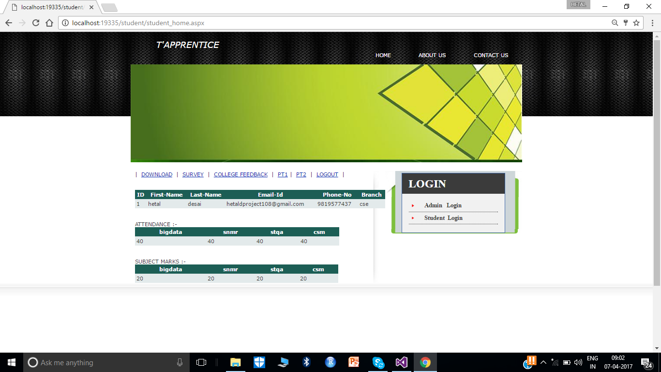

**Figure 18. Student Home Page**

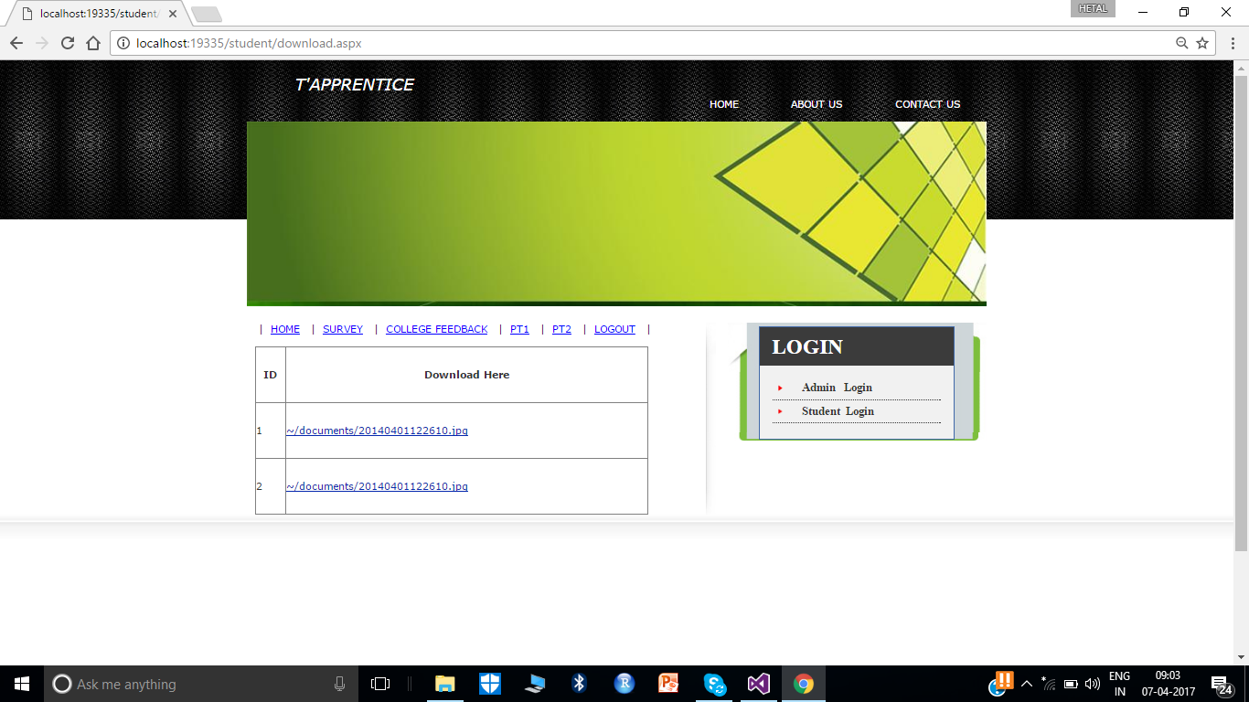

**Figure 19. Upload Page**

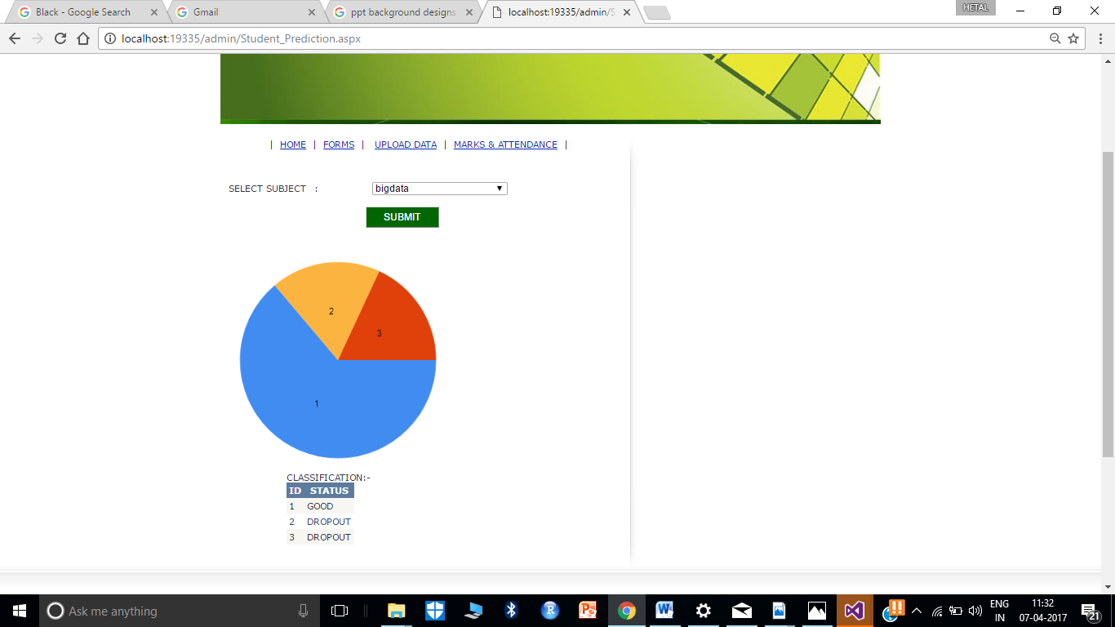

**Figure 20 Admin Prediction Page**

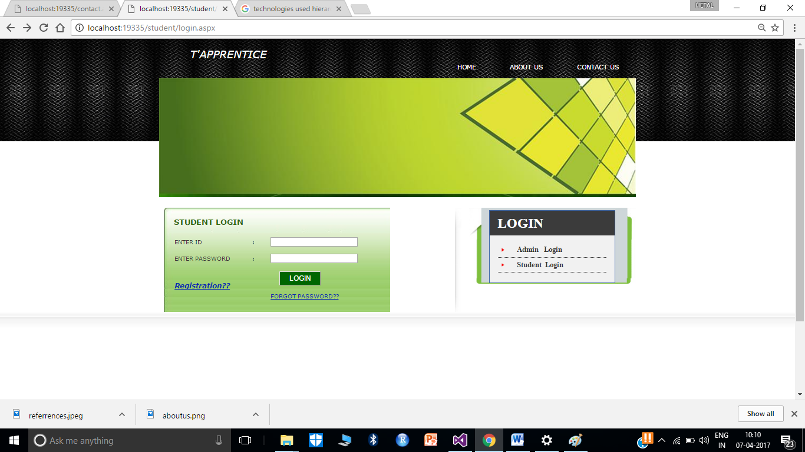

**Figure 21. Student Login Page**

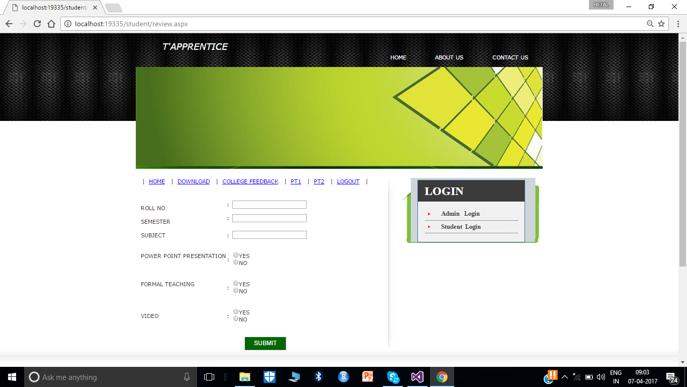

**Figure 22. Survey Page**

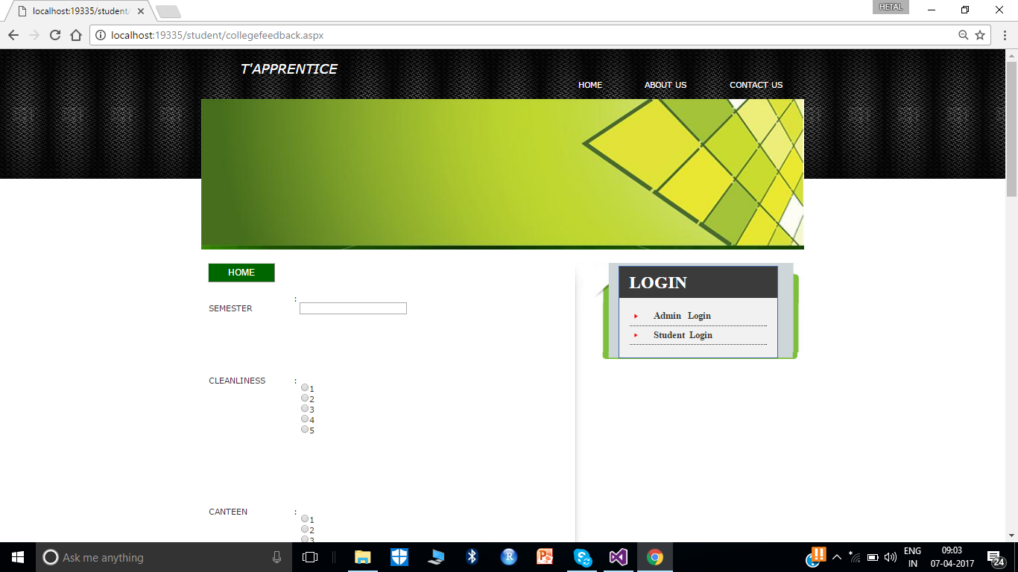

**Figure 23. Feedback Page**

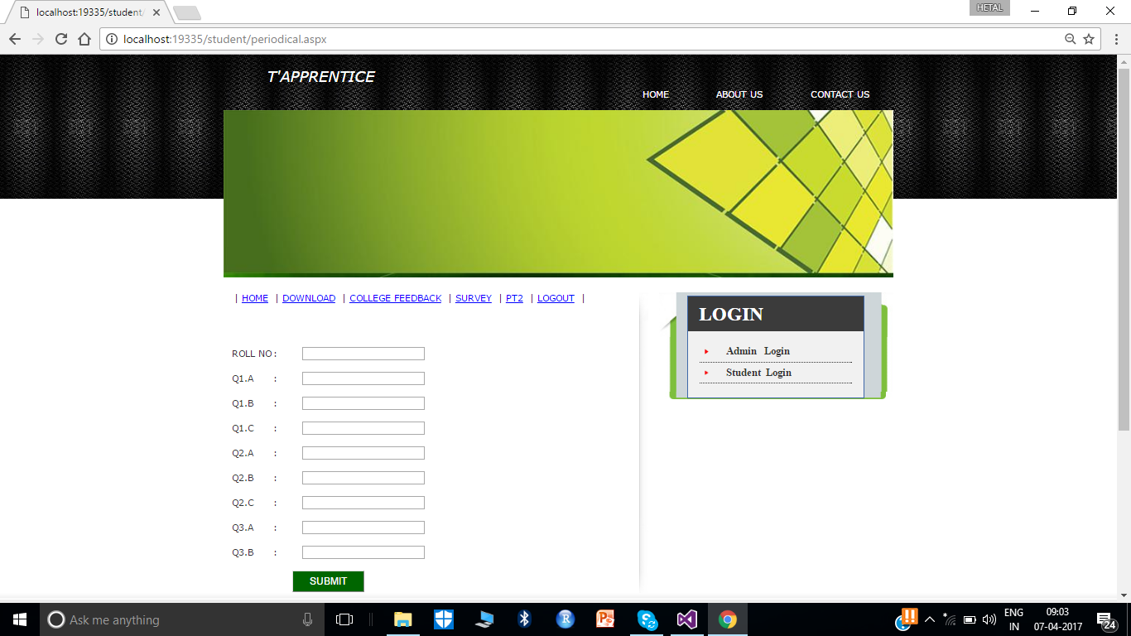

**Figure 24. PT 1 Page**

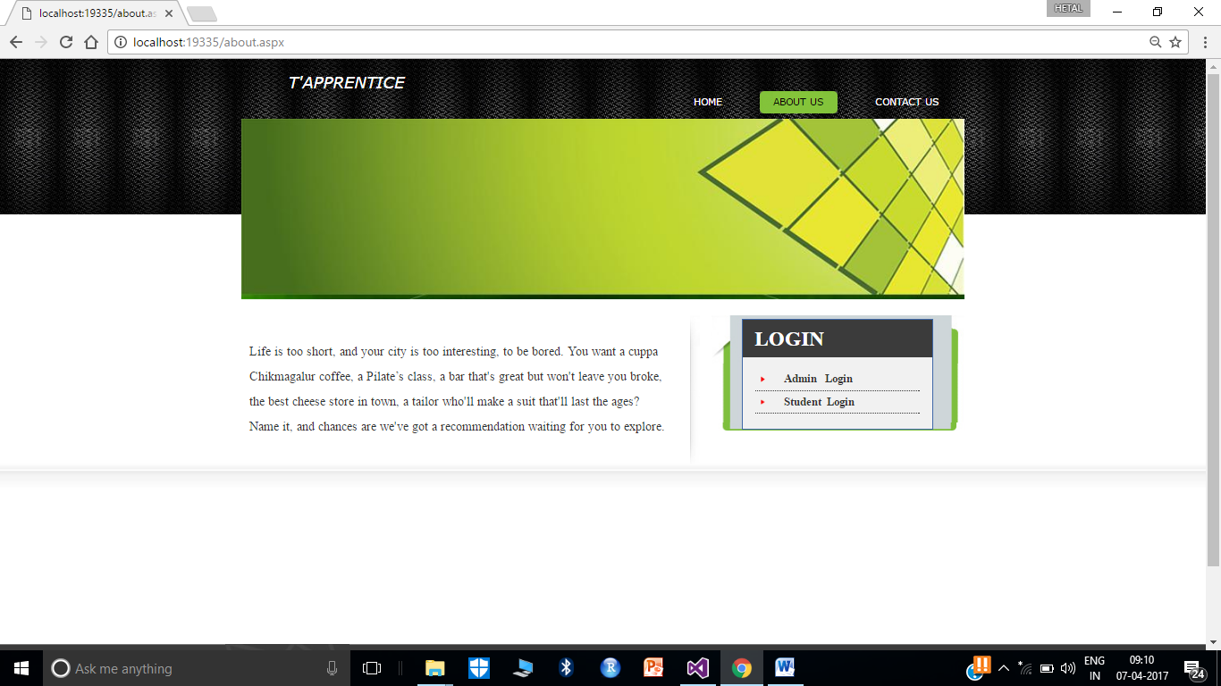

**Figure 25. About Us Page**

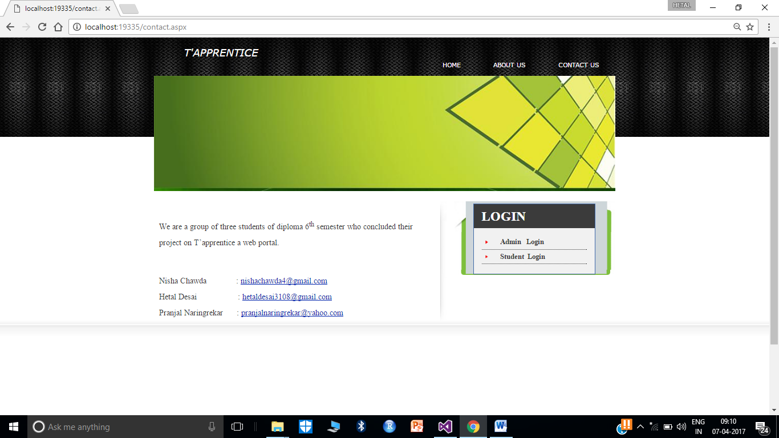

**Figure 26. Contact Us Page**



**ADVANTAGES**

**ADVANTAGES**

**________________________________________________________**

* Using the software over the Internet — simply sign up and you’re ready to go.
* The assurance of data security.
* Flexibility and portability
* No overhead of manually entering data.
* Teachers are provided with the facility of taking certain actions based on the outcome of the analysis of student’s performance.
* Increased and easier communications with faculty.
* Online access to grades
* Increased life-long learning opportunities.
* Real-time communications with students.



**LIMITATIONS**

**LIMITATIONS**

**__________________________________**

* Vulnerable to some threats.
* Only imports data in the form of an excel sheet.
* Cannot spawn forms dynamically.
* It is equipped for only a specific semester.
* Students cannot acquiesce assignments online.
* Student can only view data but not manipulate it.



**APPLICATIONS**

**APPLICATIONS**

**________________________________________________________**

* Used for data storage.
* Used to perform analysis on students marks to predict their future performance.
* To cluster information through forms.
* To creep marks and attendance.
* To glimpse crucial data.
* To supervise information.



**FUTURE SCOPE**

**FUTURE SCOPE**

**________________________________________________________**

* For a full-fledged system one can spawn semester wise classification of student’s record.
* Revamp security.
* Can import data in the form of spreadsheet, text file, access etc.
* Dynamic forms can be spawned.
* Students will be able to abide assignments online.



**CONCLUSION**

**CONCLUSION**

**________________________________________________________**

There was clear evidence prior to this project that a manual podcasting process does not scale to an institutional level. This has been confirmed in this project and through experience. We were able to demonstrate that it is possible to arrive at an institutional podcasting process, which is cost effective.

Coordination within the institution is required between a range of services, including technical services, creative services, institutions responsible for communications, and academics. In the deployment of institutional podcasting, there needs to be a clear path, developed in collaboration with those individuals who are keen to trial new technologies. A "wait and see" approach can easily lead to an unmanageable backlog of work.

The use of the technology plays a key part in institutional podcasting. However, depending on the technologies chosen, these can both enable and stifle. It is important to draw on experiences of others, and to apply those experiences intelligently within one's own institution.



**REFERENCES**

**REFERENCES**

**________________________________________________________**

* <http://it.guldstadsgymnasiet.se/c%23/C%23%205.0%20in%20a%20Nutshell,%205th%20Edition.pdf>
* <https://s3-ap-southeast-1.amazonaws.com/mylekha-ebook/IT+%26+Programming/asp.net/Beginning-ASP.NET-for-Visual-Studio-2015.pdf>
* <https://www.microsoft.com/en-in/download/details.aspx?id=44915>
* <http://www.teacherdashboard365.com/>
* <https://www.tutorialspoint.com/software_engineering/software_engineering_tutorial.pdf>
* <https://msdn.microsoft.com/en-us/library/ff926074.aspx>
* <https://classroom.microsoft.com/>
* <http://www.microsoft.com/liveatedu/free-hosted-student-email.aspx>



**ABOUT US**

**ABOUT US**

**________________________________________________________**

Life is too short, and your city is too interesting, to be bored. You want a cuppa Chikmagalur coffee, a Pilate’s class, a bar that's great but won't leave you broke, the best cheese store in town, a tailor who'll make a suit that'll last the ages? Name it, and chances are we've got a recommendation waiting for you to explore.

We are a group of three students of diploma 6th semester who concluded their project on T’apprentice a web portal.

Nisha Chawda : [nishachawda4@gmail.com](mailto:nishachawda4@gmail.com)

Hetal Desai : [hetaldesai3108@gmail.com](mailto:hetaldesai3108@gmail.com)

Pranjal Naringrekar : [pranjalnaringrekar@yahoo.com](mailto:pranjalnaringrekar@yahoo.com)